## CSS Transitions

CSS transitions allows you to change property values smoothly, over a given duration.

in this chapter you will learn about the following properties:

* transition
* transition-delay
* transition-duration
* transition-property
* transition-timing-function

## Browser Support for Transitions

The numbers in the table specify the first browser version that fully supports the property.

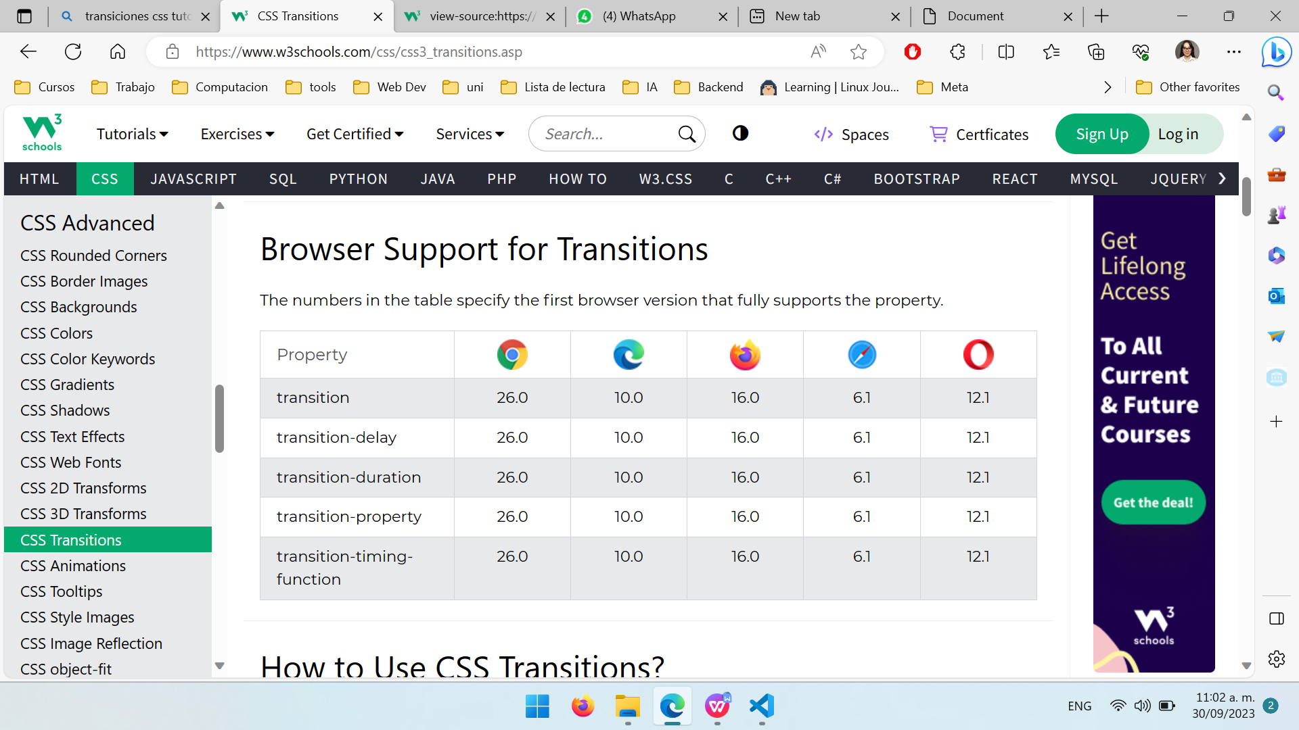

## How to Use CSS Transitions?

To create a transition effect, you must specify two things:

* the CSS property you want to add an effect to
* the duration of the effect

**Note:** If the duration part is not specified, the transition will have no effect, because the default value is 0.

The following example shows a 100px \* 100px red <div> element. The <div> element has also specified a transition effect for the width property, with a duration of 2 seconds:

## Delay the Transition Effect

The transition-delay property specifies a delay (in seconds) for the transition effect.

The following example has a 1 second delay before starting

**Note:** The auto value is often a very complex case. The specification recommends not animating from and to auto. Some user agents, like those based on Gecko, implement this requirement and others, like those based on WebKit, are less strict. Using animations with auto may lead to unpredictable results, depending on the browser and its version, and should be avoided.

# -webkit-transition:

Esta deprecado y no se recomienda su uso.

Using transitions with javascript

**Note:** Care should be taken when using a transition immediately after:

* adding the element to the DOM using .appendChild()
* removing an element's display: none; property.

This is treated as if the initial state had never occurred and the element was always in its final state. The easy way to overcome this limitation is to apply a setTimeout() of a handful of milliseconds before changing the CSS property you intend to transition to.

### [Detecting the start and completion of a transition](https://developer.mozilla.org/en-US/docs/Web/CSS/CSS_transitions/Using_CSS_transitions" \l "detecting_the_start_and_completion_of_a_transition)

You can use the [transitionend](https://developer.mozilla.org/en-US/docs/Web/API/Element/transitionend_event" \o "transitionend) event to detect that an animation has finished running. This is a [TransitionEvent](https://developer.mozilla.org/en-US/docs/Web/API/TransitionEvent) object, which has two added properties beyond a typical [Event](https://developer.mozilla.org/en-US/docs/Web/API/Event) object:

propertyName

A string indicating the name of the CSS property whose transition completed.

elapsedTime

A float indicating the number of seconds the transition had been running at the time the event fired. This value isn't affected by the value of [transition-delay](https://developer.mozilla.org/en-US/docs/Web/CSS/transition-delay).

As usual, you can use the [addEventListener()](https://developer.mozilla.org/en-US/docs/Web/API/EventTarget/addEventListener" \o "addEventListener()) method to monitor for this event:

### [Detecting the start and completion of a transition](https://developer.mozilla.org/en-US/docs/Web/CSS/CSS_transitions/Using_CSS_transitions" \l "detecting_the_start_and_completion_of_a_transition)

You can use the [transitionend](https://developer.mozilla.org/en-US/docs/Web/API/Element/transitionend_event" \o "transitionend) event to detect that an animation has finished running. This is a [TransitionEvent](https://developer.mozilla.org/en-US/docs/Web/API/TransitionEvent) object, which has two added properties beyond a typical [Event](https://developer.mozilla.org/en-US/docs/Web/API/Event) object:

propertyName

A string indicating the name of the CSS property whose transition completed.

elapsedTime

A float indicating the number of seconds the transition had been running at the time the event fired. This value isn't affected by the value of [transition-delay](https://developer.mozilla.org/en-US/docs/Web/CSS/transition-delay).

As usual, you can use the [addEventListener()](https://developer.mozilla.org/en-US/docs/Web/API/EventTarget/addEventListener" \o "addEventListener()) method to monitor for this event:

## Syntax

Return the transition property:

object.style.transition

Set the transition property:

object.style.transition*= "property duration timing-function delay*|initial|inherit"

## Property Values

|  |  |
| --- | --- |
| **Value** | **Description** |
| *[transitionProperty](https://www.w3schools.com/jsref/prop_style_transitionproperty.asp)* | Specifies the name of the CSS property the transition effect is for |
| *[transitionDuration](https://www.w3schools.com/jsref/prop_style_transitionduration.asp)* | Specifies how many seconds or milliseconds the transition effect takes to complete |
| *[transitionTimingFunction](https://www.w3schools.com/jsref/prop_style_transitiontimingfunction.asp)* | Specifies the speed curve of the transition effect |
| *[transitionDelay](https://www.w3schools.com/jsref/prop_style_transitiondelay.asp)* | Defines when the transition effect will start |
| initial | Sets this property to its default value. [Read about initial](https://www.w3schools.com/cssref/css_initial.asp) |
| inherit | Inherits this property from its parent element. [Read about inherit](https://www.w3schools.com/cssref/css_inherit.asp) |

## Technical Details

|  |  |
| --- | --- |
| **Default Value:** | all 0 ease 0 |
| **Return Value:** | A String, representing the transition property of an element |
| **CSS Version** | CSS3 |

Las **transiciones CSS** permiten animar los cambios de las propiedades CSS, en lugar de que los cambios surtan efecto de manera instantánea. Por ejemplo, si cambias el color de un elemento de blanco a negro, normalmente el cambio es instantáneo. [Al habilitar las transiciones CSS, el cambio sucede en un intervalo de tiempo que puedes especificar, siguiendo una curva de aceleración que puedes personalizar 1](https://developer.mozilla.org/es/docs/Web/CSS/CSS_Transitions/Using_CSS_transitions" \t "https://www.bing.com/_blank)[2](https://developer.mozilla.org/es/docs/Web/CSS/CSS_Transitions" \t "https://www.bing.com/_blank).

Por otro lado, las **transformaciones CSS** permiten mover, rotar, escalar o inclinar elementos. CSS permite realizar transformaciones 2D y 3D. [Las transformaciones en principio son estáticas: es decir, no están animadas (aunque pueden estarlo mediante transiciones o animaciones)](https://pedroprieto.github.io/post/transiciones_css/" \t "https://www.bing.com/_blank)

Por otro lado, las **animaciones CSS** permiten crear efectos más complejos y personalizados que las transiciones. [Las animaciones constan de dos componentes: un estilo que describe la animación CSS y un conjunto de fotogramas que indican su estado inicial y final, así como posibles puntos intermedios en la misma](https://www.digitalbiotope.net/2022/02/18/la-principal-diferencia-entre-animaciones-y-transiciones-css/" \t "https://www.bing.com/_blank)

[Transitions](https://css-tricks.com/almanac/properties/t/transition/) in CSS are applied to an element and specify that when a property changes it should do so over gradually over over a period of time. [Animations](https://css-tricks.com/almanac/properties/a/animation/) are different. When applied, they just run and do their thing. They offer more fine-grained control as you can control different stops of the animations.

### **Manipulating CSS Transitions**

There are countless questions on coding forums related to triggering and pausing an element’s transition. The solution is actually quite simple using JavaScript.

To trigger an element’s transition, toggle a class name on that element that triggers it.

To pause an element’s transition, use [getComputedStyle](https://developer.mozilla.org/en-US/docs/Web/API/window.getComputedStyle) and getPropertyValue at the point in the transition you want to pause it. Then set those CSS properties of that element equal to those values you just got.

The following is an example of that approach.

https://css-tricks.com/controlling-css-animations-transitions-javascript/